COS 10029- FUNDAMENTALS OF PROGRAMMING
Name: Sovithyea Prach
Student ID: 105270743
Task 8.1
Code:
#include <iostream>
#include <fstream>
#include <cstdlib>
#include <string>
using namespace std;

int main()
{
int count, id;
float price, min, max, avg, total=0.0;

ifstream inFile;

inFile.open("price.dat.txt");
inFile >> count;

for(int i=0; i<count; i++)
{
inFile>>id>>price;
if(i==0)
max = min = price;
if(price > max)
max = price;
if(price < min)
min = price;
total+=price;
}

avg = total / count;

ofstream outFile;
outFile.open("output.dat.txt");

cout<<"Number of price readings: "<< count <<endl;
cout<<"Maximum price: "<< max<<endl;
cout<<"Minimum price: "<<min<<endl;
cout<<"Average price: "<<avg<<endl;

inFile.close();

return 0;
}

Output:
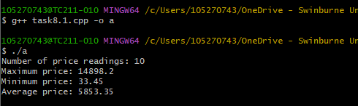
Task 8.2
Code:
#include <iostream>
#include <fstream>
using namespace std;

struct student
{
string name;
int marks[4];
};

int main()
{
int i=0, j=0, sum=0;
float avg=0.0;

student s[5];
ifstream inFile;
ofstream outFile;

inFile.open("grades.txt");

if(inFile.fail())
{
cout<<"The file was not succcesfully open.";
exit(1);
}

while(not inFile.eof())
{
inFile>>s[i].name;

for(j=0; j<4; j++)
{
inFile>>s[i].marks[j];

}
i++;
}

inFile.close();
outFile.open("gradesoutput.txt");
for(int i=0;i<5;i++)
{
outFile<<s[i].name<<endl;

for(j=0;j<4;j++)
{
outFile<<s[i].marks[j]<<endl;
sum+=s[i].marks[j];
}
avg=sum/4.0;
outFile<<s[i].name<<" has an average score of "<<avg<<endl;
}
}
Output:
